Topic điều khiển: node_dt010133_remote

“tien” => tiến xe , “trai” => rẽ trái, “phai” => rẽ phải

“lui” => lùi xe, “dung” => dừng xe

“star” => quay radar, “stop”

Điều khiển camera:

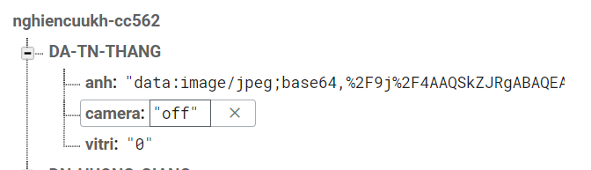

Dùng realtime firebase, bắn “on” “off” vào mục camera của thư mục gốc DA-TN-THANG  
cái này tui sẽ gửi pass firebase cho cụ ngâm cíu.

App có login và logout